Tatton Wildlife Newsletter – Spring
The anticipated arrival of spring brings more opportunity to explore the parkland and the wonderful nature that Tatton has to offer. The longer days and hopefully, better weather, triggers behavioural changes in animals and birds while plants and trees reawaken.
Birds
Arguably, spring is the favourite season for many birdwatchers. New summer migrants arrive in fresh breeding plumage, birds become more vocal as they defend a territory or attract a mate. The first arrival is usually a sand martin seen over Tatton Mere in early March. Wheatears will pass through, and the Mill Pool or Scout Camp tracks are good places to see them. Swallows, martins, and warbler species soon follow adding colour and sound to the spring landscape.
Replacement barn owl boxes have been erected and we hope to have breeding success again as we have now for several years. There were 205 recorded breeding sites in Cheshire last year producing 592 chicks.
Deer
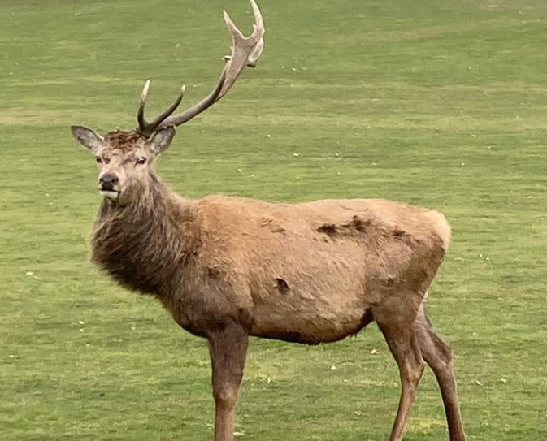
Our herds of red and fallow deer will now moult into their summer coats. The red deer change to a deep russet colouration and the fallow become more speckled and brighter. In addition to the common fallow deer there are three other variations of coat – there is menil, which are like the common but the rear end ‘target’ stripes are brown and not black. The white ones are leucistic and the black, melanistic. All four varieties can be seen here at Tatton.
The antlers are cast at this time of year and the new ones begin to grow immediately, the antler is now soft and covered in velvet and they will grow rapidly.
Rare Breed Sheep
Our Hebridean and Soay flocks of sheep are now lambing. These hardy, primitive breeds lamb outside and rarely need assistance, unlike domesticated sheep. Often, interference can lead to far more problems of lamb abandonment. And like the parkland deer, they benefit from as little disturbance as possible. Most will have twins although some will succumb to fox predation.
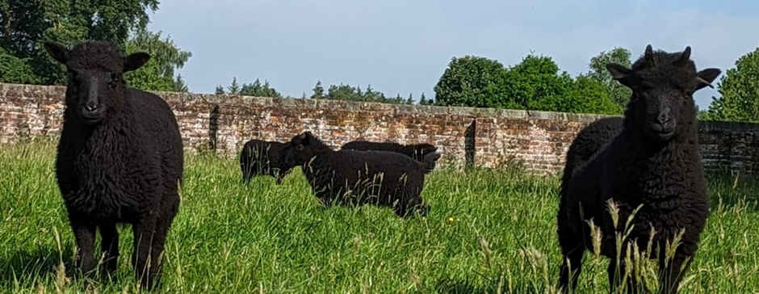

Spring Woodlands
The amphibian activity in Tatton’s ponds begins from as early as mid-February. Spawning early gives their young the whole spring and summer to grow rapidly and metamorphose into adulthood before the following winter. The dead and decaying wood left in our woodlands provides excellent habitat for frogs, toads, and newts – both for hibernation in the winter and to hunt for invertebrate prey in the warmer months.
Spring is also a great time for both wildflowers and tree blossom which provide an early nectar source for bees, butterflies, and other insects. Before the trees are fully in leaf, wildflowers make the most of light reaching the ground – bluebells, wood anemone, marsh marigold, and lesser celandine are some of the species to look out for, with Dog Wood providing some of the best viewing. The thinning work undertaken in Tatton’s woodlands has enabled wildflowers to flourish by decreasing the canopy cover and opening glades.

Compiled by Tatton’s Ranger Team

